|  |  |
| --- | --- |
| Assignment Date | 14 September 2022 |
| Student Name | Vignesh S |
| Student Roll Number | 2019504606 |
| Maximum Marks | 2 Marks |

ASSIGNMENT-1 SMART HOME AUTOMATION

**Circuit Design:**

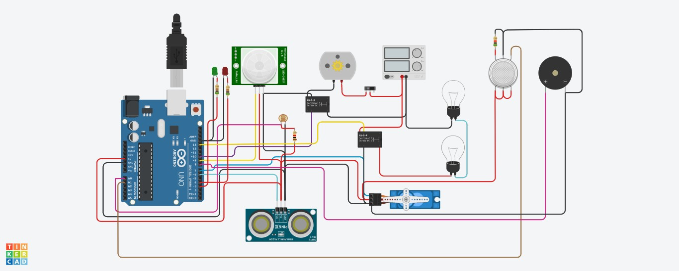

Source code:

#include <Servo.h>

|  |  |  |  |
| --- | --- | --- | --- |
| Int  int | output1Value =0;  sen1Value = 0; | | |
| int | sen2Value = 0; | | |
| int | const gas_sensor | = | A1; |
| int | const LDR = A0; | | |
| int | limit = 400; | | |
| long readUltrasonicDistance(int triggerPin, int echoPin) | | | |
| { | | | |
| pinMode(triggerPin, OUTPUT); // Clear the trigger | | | |

|  |  |
| --- | --- |
| digitalWrite(triggerPin, LOW); | |
| delayMicroseconds(2); | |
| // Sets the trigger pin to HIGH state for 10 microseconds | |
| digitalWrite(triggerPin, HIGH); | |
| delayMicroseconds(10); | |
| digitalWrite(triggerPin, LOW); | |
| pinMode(echoPin, INPUT); | |
| // Reads the echo pin, and returns the sound wave travel time in microseconds | |
| return pulseIn(echoPin, HIGH); | |
| } | |
| Servo servo_7; | |
| void setup() | |
| { | |
| Serial.begin(9600); | //initialize serial communication |
| pinMode(A0, INPUT); | //LDR |
| pinMode(A1,INPUT); | //gas sensor |
| pinMode(13, OUTPUT); | //connected to relay |
| servo_7.attach(7, 500, 2500); //servo motor | |
| pinMode(8,OUTPUT); | //signal to piezo buzzer |
| pinMode(9, INPUT); | //signal to PIR |
| pinMode(10, OUTPUT); | //signal to npn as switch |
| pinMode(4, OUTPUT); | //Red LED |
| pinMode(3, OUTPUT); | //Green LED |
| } | |
| void loop() | |
| { | |
| //------light intensity control // | |
| // | |
| int val1 = analogRead(LDR); | |
| if (val1 > 500) | |
| { | |
| digitalWrite(13, LOW); | |
| Serial.print("Bulb ON = "); | |
| Serial.print(val1); | |
| } | |
| else | |
| { | |
| digitalWrite(13, HIGH); | |
| Serial.print("Bulb OFF = "); | |
| Serial.print(val1); | |

|  |
| --- |
| } |
| // |
| //------ light & fan control // |
| // |
| sen2Value = digitalRead(9); |
| if (sen2Value == 0) |
| { |
| digitalWrite(10, LOW); //npn as switch OFF |
| digitalWrite(4, HIGH); // Red LED ON,indicating no motion |
| digitalWrite(3, LOW); //Green LED OFF, since no Motion detected |
| Serial.print(" || NO Motion Detected " ); |
| } |
| if (sen2Value == 1) |
| { |
| digitalWrite(10, HIGH);//npn as switch ON |
| delay(3000); |
| digitalWrite(4, LOW); // RED LED OFF |
| digitalWrite(3, HIGH);//GREEN LED ON , indicating motion detected |
| Serial.print(" || Motion Detected! " ); |
| } |
| delay(300); |
| // |
| // ------- Gas Sensor // |
| // |
| int val = analogRead(gas_sensor); //read sensor value |
| Serial.print("|| Gas Sensor Value = "); |
| Serial.print(val); //Printing in serial monitor |
| //val = map(val, 300, 750, 0, 100); |
| if (val > limit) |
| { |
| tone(8, 650); |
| } |
| delay(300); |
| noTone(8); |
| // |
| //------- servo motor // |
| // |
| sen1Value = 0.01723 * readUltrasonicDistance(6, 6); |
| if (sen1Value < 100) |
| { |
| servo_7.write(90); |

|  |
| --- |
| Serial.print(" || Door Open! ; Distance = "); |
| Serial.print(sen1Value); |
| Serial.print("\n"); |
| } |
| else |
| { |
| servo_7.write(0); |
| Serial.print(" || Door Closed! ; Distance = "); |
| Serial.print(sen1Value); |
| Serial.print("\n"); |
| } |
| delay(10); // Delay a little bit to improve simulation performance |
| } |

Output: [Below is Part of Output]. Running the code gives the full output.

